**DAILY ONLINE ACTIVITIES SUMMARY**

|  |  |  |  |  |  |  |
| --- | --- | --- | --- | --- | --- | --- |
| **Date:** | **02-06-2020** | | | **Name:** | **B.A.SOHANKUMAR** | |
| **Sem & Sec** | **4TH SEM A** | | | **USN:** | **4AL18CS013** | |
| **Online Test Summary** | | | | | | |
| **Subject** | | **--------** | | | | |
| **Max. Marks** | | **--------** | | **Score** | **-------** | |
| **Certification Course Summary** | | | | | | |
| **Course** | **1. INTRODUCTION TO DATA STUDIO**  **2. STEP INTO ROBOTIC PROCESS AUTOMATION** | | | | | |
| **Certificate Provider** | | | **1.GOOGLE ANALYTICS ACADEMY**  **2.GUVI** | **Duration** | | **1. 4.5 HOURS**  **2. 3 HOURS** |
| **Coding Challenges** | | | | | | |
| **Problem Statement:1:Give an array arr[] of size N and an integer K .The task is to find the count of sub arrays such that each subarray has exactly K distinct elements.**  **Problem Statement:2:Write a java program to find perfect sum problem.**  **Problem Statement:3:Write a program in java, an array of integer data to be initialized.** | | | | | | |
| **Status: EXECUTED** | | | | | | |
| **Uploaded the report in Github** | | | | **YES** | | |
| **If yes Repository name** | | | | **LOCKDOWN CODING** | | |
| **Uploaded the report in slack** | | | | **YES** | | |

**CERTIFICATION COURSE DETAILS:**

**1.Course:** INTRODUCTION TO DATA STUDIO

In today's certification course I have completed the 2 modules which contains Connect data,Creating a new report and adding charts,Adding and configuration of report controls,Share reports,Data visualization basics,Create and use report templates.And completed with 2 assessment test.



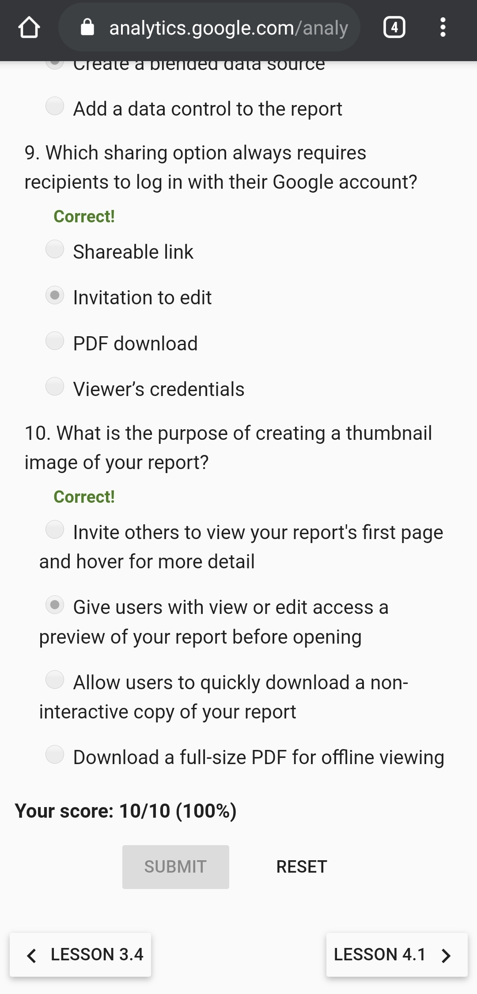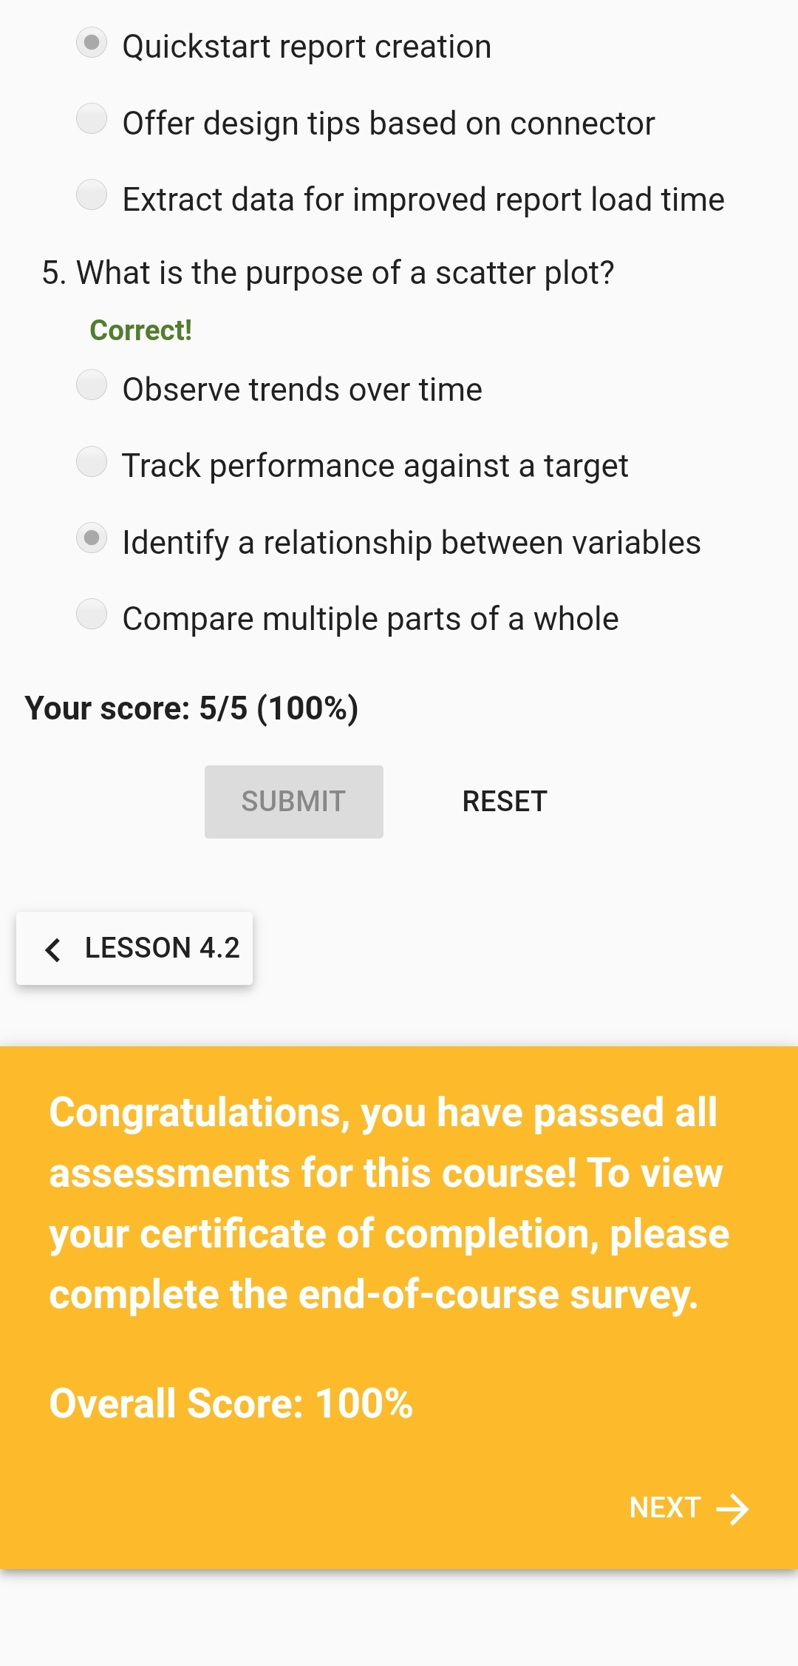

ASSESSMENT 3. ASSESSMENT 4.



**Above certificate is awarded from Google analytics academy for the completion of INTRODUCTION TO DATA STUDIO certification course.**

2. ROBOTIC PROCESS AUTOMATION

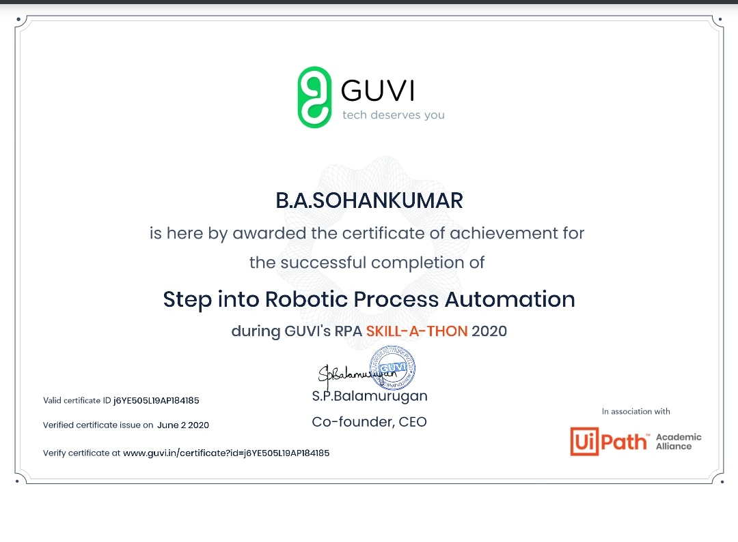

**The above certificate is awarded for completion of Step into Robotic Process Automation during GUVI's RPA SKILL-A-THON 2020.**

**CODING CHALLENGES:**

1.Give an array arr[] of size N and an integer K .The task is to find the count of sub arrays such that each subarray has exactly K distinct elements.

Examples: Input: arr[] = {2, 1, 2, 1, 6}, K = 2 Output: 7 {2, 1}, {1, 2}, {2, 1}, {1, 6}, {2, 1, 2}, {1, 2, 1} and {2, 1, 2, 1} are the only valid subarrays

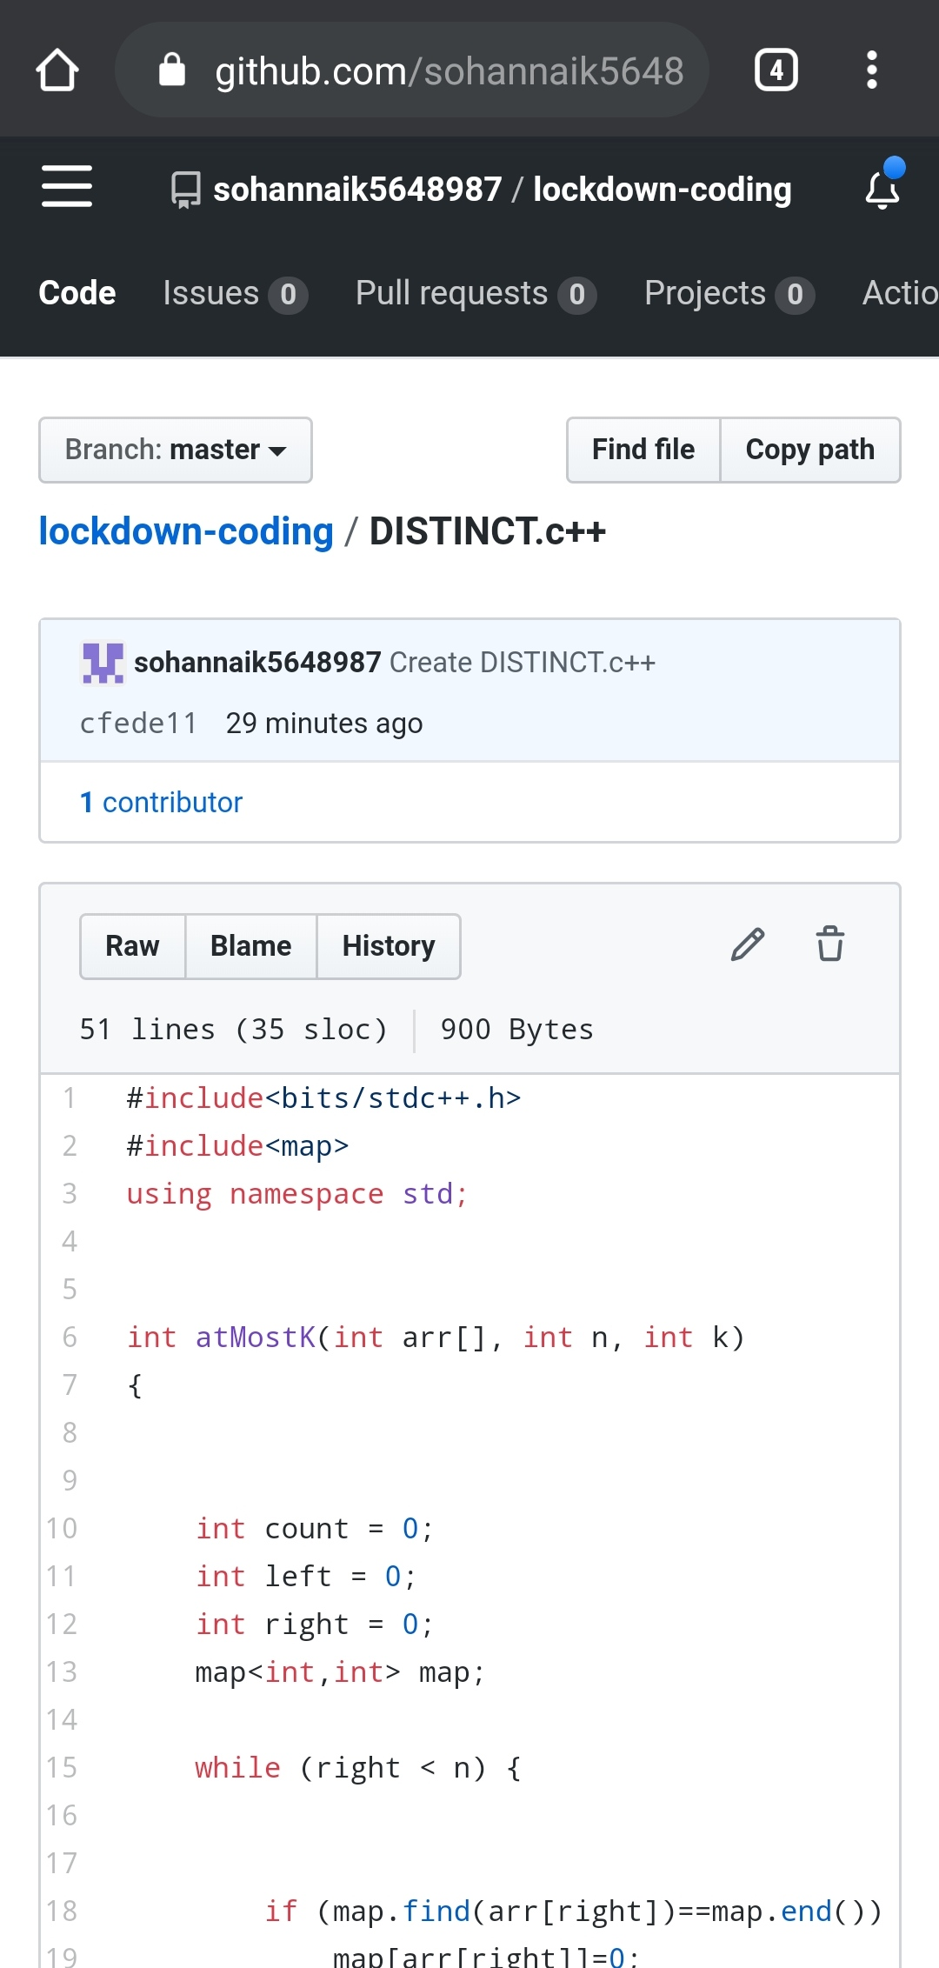

2.Write a java program to find perfect sum problem.

Given an array arr[] of integers and an integer K, the task is to print all subsets of the given array with the sum equal to the given target K.

Examples:Input: arr[] = {5, 10, 12, 13, 15, 18}, K = 30

Output: {12, 18}, {5, 12, 13}, {5, 10, 15}

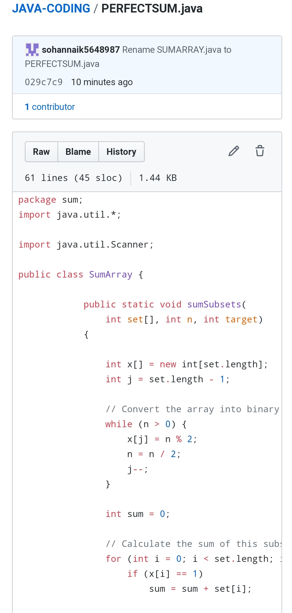

3.Write a program in java, an array of integer data to be initialized. During the initialization, if a user enters a value other than integer value, then it will throw InputMismatchException exception. On the occurrence of such an exception, your program should print “You entered bad data.” If there is no such exception it will print the total sum of the array.

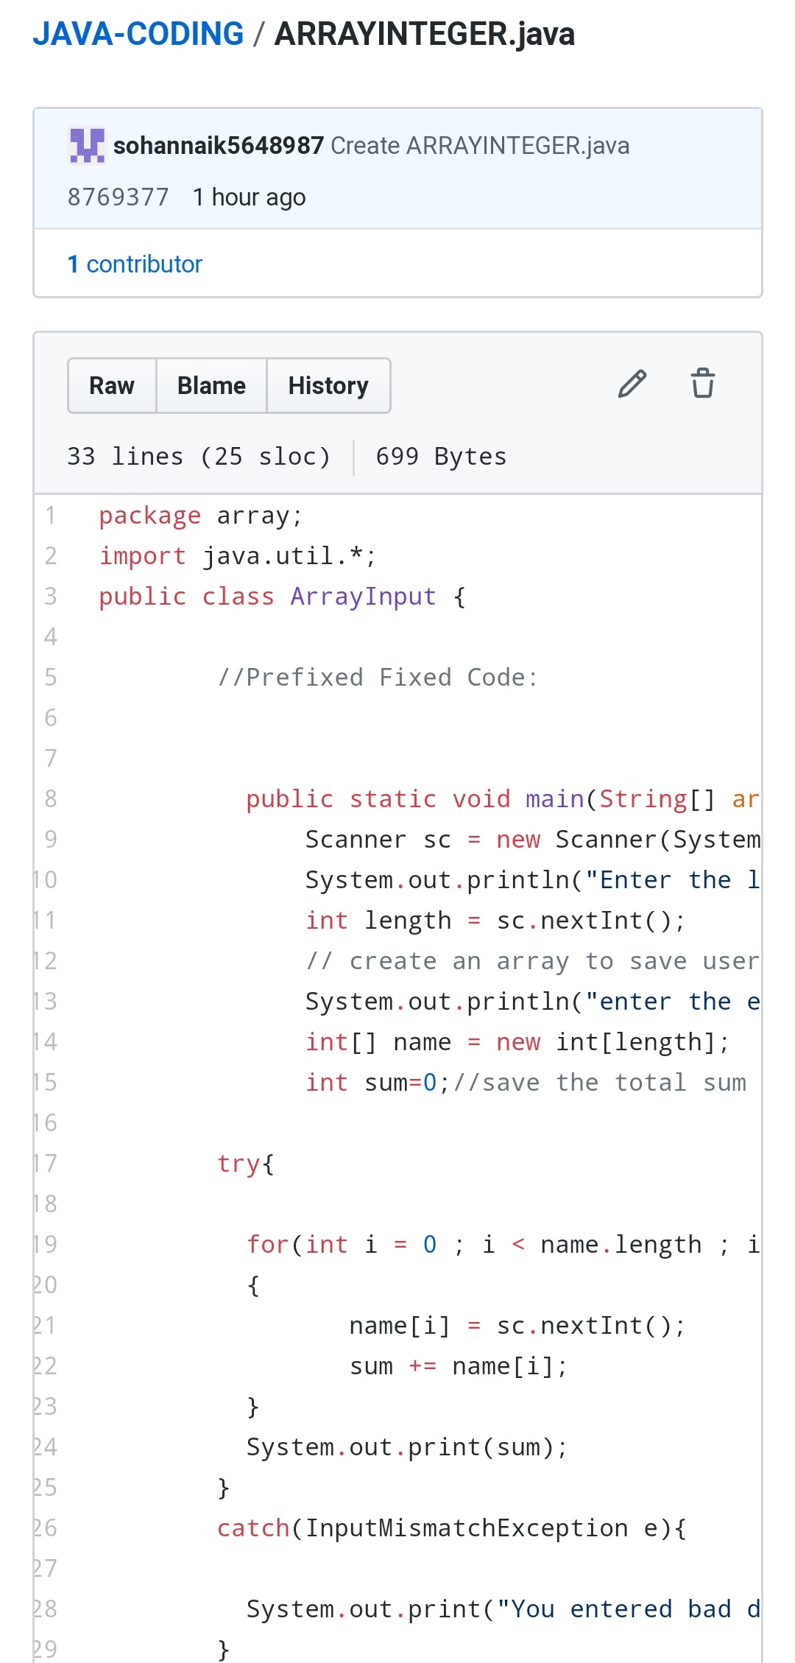

REPOSITORY LINK: https://github.com/sohannaik5648987/lockdown-coding

https://github.com/sohannaik5648987/JAVA-CODING